10 September 2012

[www.marketingsite.com](http://www.marketingsite.com) Keys communications a company that contributes passionately to township upliftment. R20 000

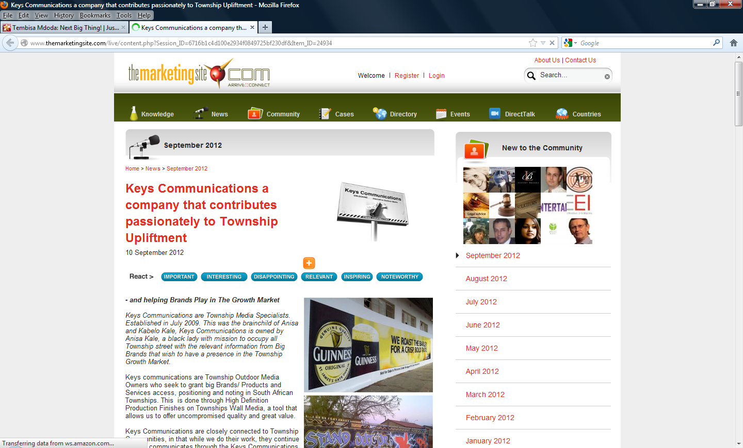

http://www.themarketingsite.com/live/content.php?Item_ID=24934